Tipperary Education and Training Board (ETB)

YOUTHREACH ADMISSIONS POLICY

**Version** 1.1

**Last updated**: 13/02/2024

Tipperary ETB Youthreach Admissions Policy

|  |  |
| --- | --- |
| Policy Area | Admissions |
| Policy Reference No. | **1.1** |
| Version | **2** |
| Document Created by | **David Young** |
| Date Amended & Short Summary of Amendments | **13.02.2024** |
| Date Reviewed / Ratified by Senior Leadership Team – CE & Directors |  |
| Date Noted  / Date Adopted  by Tipperary ETB Committee |  |
| Policy Review Date |  |
| Date of Withdrawal of Obsolete Document |  |
| Send Feedback to |  |

Table of Contents

Page

1. **Introduction 4**
2. **Eligibility 6**
3. **Enrolment Protocol 7**
4. **Admissions Procedures 7**
5. **Appreals Procedures 8**
6. **Implementation & Review 9**
7. **Monitoring Evidence of Implementation 9**

* **Appendix A: Expression of Interest Form 10**
* **Appendix B: Additional Information 11**

1. Introduction

Tipperary Education and Training Board’s (TETB) Statement of Strategy 2023-2027 sets out key strategic goals and priorities. It also outlines TETB’s vision, mission add values

**Vision**

To be a progressive organisation that enriches lives, offering innovative education and training opportunities.

**Mission**

To provide a quality education and training service, which creates diverse opportunities enabling learners and communities to unlock their potential.

**Values**

The consultation process endorsed the five core ETB national values as our own, and these will guide the organisation going forward.

Excellence

We aim for excellence in all aspects of our work as an ETB. We are committed to achieving the highest quality standards of teaching and learning, and in the delivery of all our services. We value innovation and seek to achieve continuous improvement, supporting our staff to engage in professional development opportunities.

Care

We care for the welfare, wellbeing and safety of our students and staff by creating safe and welcoming environments for learning and working. We have a culture that recognises and celebrates the achievements of students and staff.

Equality

We strive to ensure that all students, staff and members of our communities are afforded equal opportunity to participate in education and training, and that our work is based on a core respect for human rights and diversity. Our ways of working create an environment and culture where everyone feels involved, consulted and valued. We do this by listening and being open to other perspectives, respecting diversity and valuing alternative views.

Community

Our Tipperary ETB community includes our staff, our students and our partners, working together to achieve our collective goals. We are closely linked to communities in which our services are provided. We value our partnerships with community groups and organisations to bring social, cultural and economic benefits to the county.

Respect

Tipperary ETB promotes equality of opportunity and treatment for staff and all people who avail of our services. We operate within a culture of accountability, fairness, honesty and inclusion. This culture is exemplified in the relationships between all members of the Tipperary ETB community and is reflected in the decision-making processes we use. Our focus is to impact positively on the rights and aspirations of the diversity of people within the Tipperary ETB community. We treat every person with respect and protect the human rights of our students, staff and all persons to whom we provide services.

Youthreach is the principal national response in Ireland to the difficulties faced by young people who have left school early. It is an education and training programme targeting, in particular, those between 16 and 20 years of age who have left the mainstream school system with poor qualifications or none. The Youthreach programme aims to provide early school leavers with the knowledge, skills and confidence required to participate fully in society and progress to further education, training and employment. Youthreach is part of TETB’s education service.

* 1. Purpose

The purpose of this policy is to provide clear admission procedures that will be applied consistently and in a fair and transparent manner.

* 1. Scope

This policy applies to all Tipperary ETB Youthreach management, staff and all applicants to our courses.

* 1. Other Relevant Policies and legislation

This Admissions Policy has been drawn up in accordance with the principles ofthe provisions from the Education (Admission to Schools) Act 2018 which relate to enrolment in schools. However, it should be noted that Education (Admission to Schools) Act 2018 doesn’t apply in Youthreach Centres. This policy aims to give clear understanding of the criteria and process required which is in accordance with the Operator Guidelines for the Youthreach Programme, April 2015, as set down by the DES and latest Eligibility for FET V1.0 document.

1. Eligibility

To be eligible for the Youthreach Programme learners should:

* be aged between 16 and 20 years of age at the commencement of their engagement with Youthreach.
  + Those aged 15 years of age may, as an exceptional measure, also be considered eligible subject to referral to the Chief Executive (CE) of TETB for approval
* have left school
* be unemployed
* have less than upper second level education and lack competencies or skills in the area of inter-personal communications, enterprise or motivation

The age eligibility criteria may be extended up to age 25 in the case of:

* lone parents,
* learners released from detention
* drug Court participants
* individuals who have less than upper second level education and whose personal circumstances are such that the centre programme is the most appropriate option for them

Exceptions must be authorised by the CE or her/his nominee. In all such cases the grounds for making an exception must be documented and should establish how and why Youthreach is the most appropriate option.

1. Enrolment Protocol

Recruitment to Youthreach will include:

* for those who self-refer and are under 18 years of age
  + confirmation in writing from the Principal of the last school attended that the young person is no longer attending the school and/or letter of confirmation of same by the Education Welfare Officer
* for those referred by external agencies such as centres (e.g. School Completion Programme or Home School Community Liaison), executive agencies (e.g. Education Welfare Service (EWS) in TUSLA, DES, SOLAS, HSE, Gardaí, Probation Service) and NGOs (e.g. youth service, Barnardo’s, St. Vincent de Paul, etc)
  + written confirmation from external agency that the young person has left school
* Any cases of prospective learners who are under 16 years of age should be referred to the CE and/or his/her nominee
  + written confirmation from the Principal of the last school attended that the young person is no longer attending the school and/or letter of confirmation of same by the Education Welfare Officer

1. Admissions Procedures

The following outlines the procedures to be followed for admission of learner;

1. Applicant submits a completed application form to the centre ( co-signed by parent or guardian if under 18 years). See Appendix A and B
2. On receipt of completed application form by the centre, it will be date stamped
3. Form will be reviewed by the Co-ordinator
4. Eligibility will be determined
5. If deemed ineligible, applicant is notified in writing outlining reason
6. If deemed eligible, interview with applicant[1] (and parent/guardian if under 18) is scheduled
7. Applicant is, in writing, offered a place or placed on a waiting list where oversubscribed[2]

Grounds upon which Youthreach may refuse to admit an applicant include:

* If the education normally provided at the centre is not suited to the age, ability or aptitude of the child
* If admitting the applicant to the centre would:
  + Make it necessary for the centre to employ additional support staff which are not funded by the Department of Education and Skills
  + Give rise to significant expenditure on extending or altering the accommodation or facilities at the centre, which are not funded by the Department of Education and Skills
* Be likely to be seriously detrimental to order and discipline in the centre
* Be likely to be seriously detrimental to the wellbeing of staff or the other learners in the centre
* Be likely to be seriously detrimental to health and safety in the centre
* If it is established that information contained in the application is false or misleading in a material respect

Youthreach reserves the right to withdraw at any stage, the offer of a place in light of receipt of additional information following the allocation of the place.

1. Appeals Procedure

An applicant who has reached the age of 18, or the parent/guardian/the National Education Welfare Board / other statutory agency on behalf of an applicant under 18 years, may appeal the decision to refuse admission to the centre. This appeal must be made in writing (outlining as to why the young person should be given access to the Youthreach Programme) within 10 working days of the date of issue of the notification. Appeals must be addressed to the:

Adult Education Officer

Tipperary ETB

Lifelong Learning Centre

Martyrs Road

Nenagh

Co. Tipperary

An Appeals Committee will be established (comprising of members from the FET committee and/or ETB sub-committee) to hear the appeal.

1. Internal Monitoring & Review

Review to be conducted once every two years and as and when there is new changes.

1. Monitoring Evidence of Implementation
   1. Tipperary ETB monitors the implementation of this Youthreach Admissions Policy
   2. Evidence to confirm implementation of the Youthreach Admissions Policy will include, for example:

* ETB website; contacts with stakeholders,
* Intranet (if/as applicable),
* IT helpdesks,
* ETB/Training Centre Service Plans,
* Customer Charter (where appropriate),
* Promotional materials,
* Learner feedback forms and surveys,
* Follow-up survey of learners.

Appendix A: Expression of Interest Form

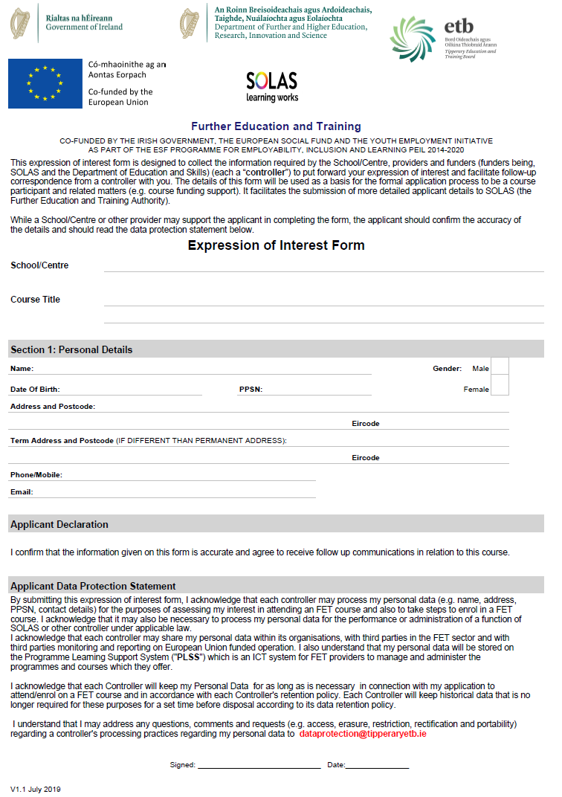

Appendix B: Additional Information

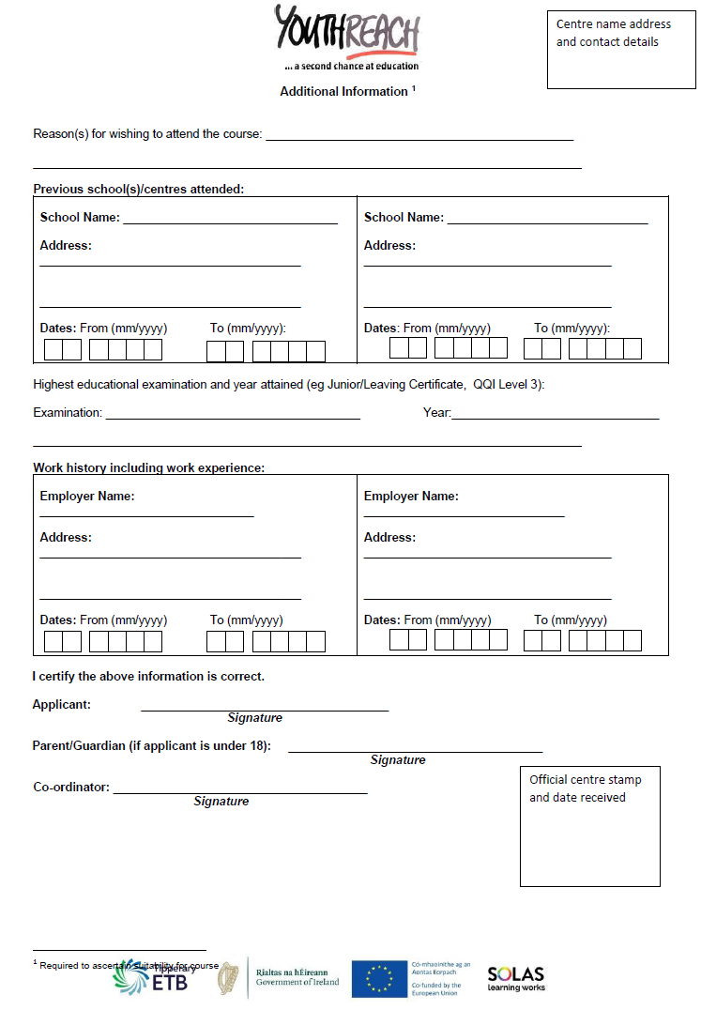

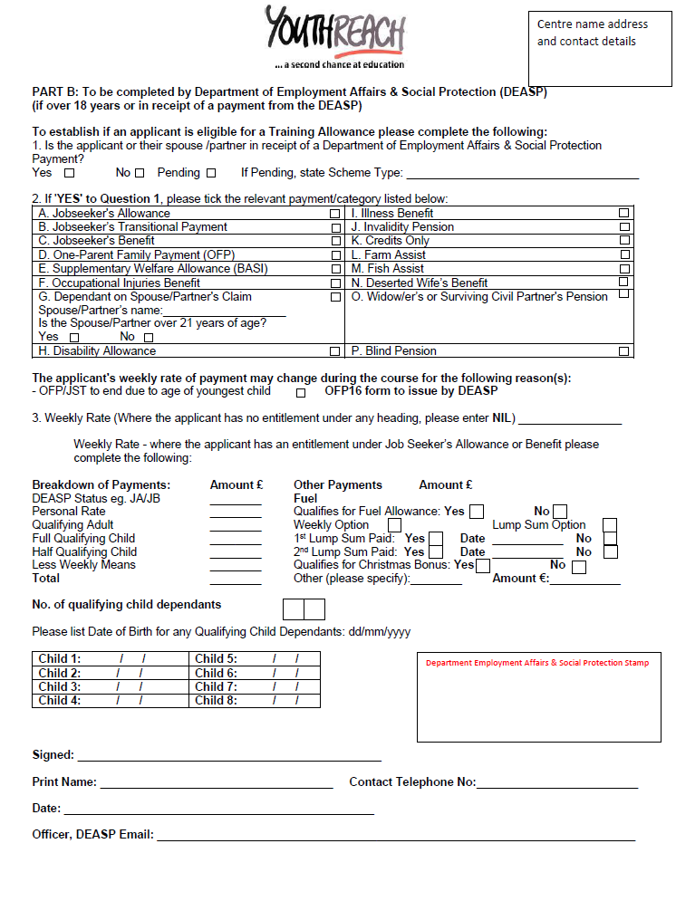

1. ‘applicant’-means the learner (if under 18) and parent or, in the case of a learner who has reached the age of 18 years, the learner, who has made an application for admission to Youthreach
2. ‘oversubscribed’- means—

   (a) in respect of the intake group, that the number of learners seeking admission is greater than the number of places being made available in respect of the intake group concerned,