Tipperary Education and Training Board (ETB)

**CÉIM EILE, TEMPLEMORE COLLEGE OF FURTHER EDUCATION (TCFE)**

**SPECIAL EDUCATIONAL NEEDS POLICY**

**Version** 1

**Last updated**: 11/07/2023

Contents

Introduction 5

Aims 6

Objectives 6

Accessing Extra Supports for Learners 8

Models of SEN Support 8

Record Keeping 8

Roles and Responsibilities of Stakeholders 9

The Learner 9

The Coordinator 9

Class/Subject Teachers including Resource Staff 10

Guidance Counsellor 10

Special Needs Assistants: 11

Board of Management 13

Parents 13

Supporting the Centre 13

Communicating with the Centre 14

Learning Support through the following Structures: 15

Withdrawal – small group/1:1 15

Resource Teacher – Learning Support through - 16

In-Class Support – Team Teaching 16

What can support teacher do? 19

Identifying Learners with Additional Needs in line with New Allocation Model 2017 21

Continuum of Support 21

The Continuum of Support suggests the following levels of support: 22

STAGE 1 CLASSROOM SUPPORT 22

STAGE 2 CENTRE SUPPORT 23

STAGE 3 CENTRE SUPPORT PLUS 23

How does Céim Eile identify Learners for high incident support/learning support? 27

Induction Meetings 27

Curriculum Review of a Learner 28

Protocol for Decision on modification of Curriculum 29

Learner Support – Emotional / Behavioural Needs 29

How does the system work? 30

Reasonable Accommodations in State Examinations 31

Key Features of the RACE Scheme 31

How is this managed within Céim Eile? 32

Irish Exemption Circular 0053/2019 34

Circulars 37

Guidelines for Centres and New Allocation Model 37

Special Education Teaching Allocation Circular No 0014/2017 https://www.education.ie/en/Circulars-and- Forms/Active-Circulars/cl0014_2017.pdf 37

Special Education Needs Circular 0070/2014 – 37

Changing Centres Moving from Primary to Post-Primary Centre Guidelines for Parents/Guardians of Learners with Special Educational Needs – 37

https://ncse.ie/wp-content/uploads/2016/01/3-NCSE-2016-Changing-Centres-final- web-27.01.16.pdf 37

Guidelines on Moving between Mainstream and Special Settings – 37

https://ncse.ie/wp- content/uploads/2016/01/2-NCSE-2016-Changing-Centres-2-final-web-27.01.16.pdf 37

Guidelines on Planning for Life after Centre 37

https://ncse.ie/wp-content/uploads/2016/01/4-NCSE-2016-Life- After-Centre-final-web-27.01.16.pdf 37

SNA 38

Application for SNA support 39

Assistive Technology 40

Relevant Circulars 40

Special Education Needs Glossary Of Terms 42

Future Objectives 46

Review 47



**Céim Eile, Templemore College of Further Education (TCFE)**

Special Educational Needs Policy

|  |  |
| --- | --- |
| Policy Area | Youthreach |
| Document Reference number | See Attached |
| Version | To be inserted by HO |
| Document Drafted by | **Céim Eile, TCFE** |
| Date Adopted by TETB | To be inserted by HO |
| Reviewed/Amendment | December 2022 |
| Date Review/Amendment Adopted | To be inserted by HO |



“Youthreach is co-funded by the Government of Ireland, the European Social Fund and the Youth Employment Initiative as part of thE European Social Fund Plus (ESF+) 2021-2027.”

Funded by the Irish Government and part-financed by the European Union under the

National Development Plan

Príomh Oifigeach Feidhmiúcháin: Bernadette Cullen

# Introduction

This policy is rooted in the mission statement and in the aims of the centre. In so doing, we wish to nurture in a caring centre environment the educational and spiritual needs of our learners, thereby producing mature, respectful, motivated and responsible people enabling them to live full and meaningful lives.

The mission statement of Céim Eile

In active partnership with the whole community, Céim Eile is committed to:

* Recognising the worth of each individual
* Educating our learner in a caring environment
* Promoting our cultural heritage
* Preparing the learner for a meaningful and spiritual life
* Contributing to the life of the community

The SEN policy and procedures are evolving and are being developed while aspiring to the following key underlying principles:

1. Ownership by the whole centre
2. Embedded in whole centre planning
3. Inclusion for all
4. Evidence Based approach
5. Staged intervention approach

# Aims

* To seek to enable all learners participate in the curriculum
* To seek to develop positive self-esteem and positive attitudes towards centre and learning
* To work towards assisting learners to take control of their learning and become independent learners;
* To provide supplementary teaching and additional support and resources for learners
* To involve parents in supporting their children’s learning
* To promote collaboration among staff in assisting learners participate fully in the curriculum
* To seek to identify learners that are finding centre challenging and endeavour to support them in these challenges

# Objectives

The objectives of our centre’s SEN policy are to:

* + To improve learning of learners with SEN;
  + To enhance their basic skills and learning strategies to a level which enables these learners to participate in the full curriculum, or to, as great an extent as is possible in the circumstances taking into account medical, psychological, NEPS and SENO advice.
  + To help achieve an adequate level of competency in literacy and mathematics by SEN learners before they leave secondary education;
  + To develop and help apply independent learning strategies with SEN learners resulting in commitment to and involvement in their own learning, positive attitudes to centre and high levels of self-esteem;
  + To develop and encourage partnership between management, class teachers, learning-support teachers and parents in planning and implementing supplementary teaching programmes for these learners.
  + To implement a tracking system at whole-centre level to monitor the progress of these learners.

All learners are supported and benefit from a variety of supports. Every effort is made to ensure that the needs of learners are met. All Learners are provided with scaffolding through a variety of built in supports. The majority of learners will progress through centre without the need for extra help or assistance.

# Accessing Extra Supports for Learners

What extra supports are available for learners and where can Céim Eile apply for them

* + SNA Support to cater for significant care needs - application on a case by case basis to Deborah Ryan, CEF Active Inclusion, Tipperary Education and Training Board (ETB)
  + Reasonable accommodation in State Examinations – State Examinations Commission

Other supports that can be utilized include:

* + Referral to Service e.g. speech and language etc.
  + Educational Welfare Officer
  + Assistive Technology - application to Special Education Needs Organiser, NCSE

# Models of SEN Support

* + Team Teaching/In-class Support
  + Small Group Withdrawal
  + Individual Withdrawal
  + Guidance

# Record Keeping

* + Copies of professional reports are held in the learner’s personal files in a locked filing cabinet
  + Copies of relevant documents including by not withstanding Irish Exemptions and Modern European Languages (MEL) are held by the Coordinator in the learner’s personal files in a locked filing cabinet
  + Copy of any previously obtained Reasonable Accommodations are held in the learner’s personal files in a locked filing cabinet

# Roles and Responsibilities of Stakeholders

## The Learner

* + Be involved in the planning process eg I do not want to be withdrawn from class, I find it hard to do my task work
  + Utilise the centre structures to communicate any concerns and suggestions to centre staff regarding their learning needs
  + Provide information about his/her own learning, talents, abilities, skills, areas of interest, likes, dislikes, subject preferences, learning style
  + Assist in setting goal and targets
  + Strive to achieve those goal and targets
  + Work with all staff in a positive way
  + Strive to participate in a wide range of cross curricular centre activities eg sports, drama, learner council, music
  + In collaboration with teachers, identify suitable enrichment opportunities for exceptionally able learners (eg WorldWiseCentres, Gaisce)

## The Coordinator

* + has overall responsibility for centre development and centre planning
  + may delegate specific functions to staff members
  + liaises with resource teachers in relation to learners with SEN
  + liaises with other teaching personnell in relation to learners with SEN
  + meets with parent(s)/guardian(s) of learners with SEN
  + liaises with SNAs in relation to learners with SEN
  + liaises with external agencies in relation to learners with SEN
  + ensures that procedures exist which ensure to smooth transfer of learner with SEN to Céim Eile
  + oversee the implementation of a whole centre assessment and screening programme to identify learners with very low achievement so that these learners can be provided with the support they need.

## Class/Subject Teachers including Resource Staff

* + Class/Subject teachers have the primary responsibility for teaching all learners, including learners with SEN
  + Accept that everyone learns differently and recognise each learners learning potential and style
  + Utilise the information they receive through various avenues re learners with SEN to inform their teaching
  + If a Class/Subject teacher has a concern then they should talk to the Coordinator
  + If a Class/Subject teacher has a concern and would like extra information then they should make contact with the a member of the Resource Team and/or Coordinator
  + Work with the SNA to support the care needs of the learner in their classroom
  + Work with the in-class support/team teacher and utilise their expertise to support inclusion of learner with SEN
  + Liaise with the Resource teacher who works with learners to seek advice and request assistance
  + Learners with special education needs are integrated into regular class as much as is possible. In some instances and where resources allow a modified curriculum may be necessary
  + Promote positive self-esteem by giving genuine praise whenever possible and promote activities that yield success
  + Resource staff are responsible for completing entrance exam on learners induction to the centre

## Guidance Counsellor

* + The input that the guidance counsellor has with a learner with SEN varies from learner to learner depending on personal circumstances
  + Provide Counselling in personal, educational and career matters
  + Be available to meet learners with SEN
  + Provide guidance to learner with SEN on curriculum matters eg subject choices
  + Provide guidance to parents of learner with SEN on curriculum matters eg curriculum choices
  + Provide information to parents of learners with SEN and Learner themselves about the implications of taking certain options eg Irish or Language Exemptions, not engaging with the Work Experience element of the Leaving Certificate Applied programme
  + Provide Support to Learner with SEN
  + Take part in Team Meeting when required and appropriate

## Special Needs Assistants:

The duties of the SNA carried out according to the guidelines for Special Needs Assistants from the Department of Education and Skills and under the direction of the coordinator/class teachers, the SNA will meet the care needs of the SEN learners to which they have been assigned. (Circular 0030/2014)

* + To provide care assistance to named learners who have special educational needs. They make a valuable contribution to the centre’s capacity to provide inclusive education to these learners.
  + To recognise their role in the health and safety of the learner and in their social, emotional and educational development, without developing a culture of dependency.
  + Attending Staff meetings when appropriate. Meeting regularly with the Coordinator to discuss any matters / issues arising.
  + Assisting / escorting learners on centre trips.
  + Giving special assistance as necessary for learners with particular difficulties e.g. helping learners with SEN with typing, writing or other use of equipment etc.
  + Assisting with specific needs, being mindful of health and safety needs of the learner as necessary when required to meet said specific needs of learners.
  + Assisting with RACE during house examinations (if appropriate).
  + Assisting the teacher in the supervision of learners during assembly, recreation and in movement from one classroom to another.
  + Accompanying individual or small groups who may be withdrawn temporarily from the classroom. **An SNA should not be asked to withdraw a learner from a classroom unless this is a strategy that has been agreed by the Coordinator, where teachers and parents / guardians will have been informed.**
  + Give general assistance to the subject teacher, under the direction of the Coordinator, of a non- teaching nature. **The SNA may not act as either substitute or temporary teachers. In no circumstances may they be left in sole charge of a class.**
  + Participation with centre development planning in Special Educational Needs, where appropriate, and co-operation with any such changes with policies and practices arising from the centre development process.
  + Engagement with parents / guardians of learners with SEN as required and directed by centre management.
  + Other appropriate duties as may be determined by the needs of the learners and the centre.
  + The SNA may be re-assigned to other appropriate work when special needs learners are absent or when particularly urgent work demands arise.
  + To treat all matters relating to centre business and their work, as strictly confidential

## Board of Management

*Post Primary Guidelines p.65*

The Board of Management has an important role in developing, supporting and monitoring centre policy on learning support and special needs. The Board of Management should:

* + Oversee the development, implementation and review of centre policy on special needs services in general
  + Ensure that adequate classroom accommodation and teaching resources are provided for the learning support teacher
  + Provide a secure facility for storage of records relating to learners in receipt of special needs and learning support services
  + Ensure that reasonable accommodation is provided for learning and for state examinations

## Parents

Parents play a vital role during the transfer from Primary to Post Primary Parents have a dual function:

* + In supporting the centre and
  + In communicating with the centre.

### Supporting the Centre

The role of the parent is to:

* Be involved in creating a positive attitude towards centre
* Be involved with individual educational planning by participating with learners in activities such as language, maths and literacy
* Liaise with the centre to gain knowledge on how to support the learners with learning difficulties e.g. best methodologies to adapt when supporting learners

### Communicating with the Centre

The role of the parent is to:

* Complete the enrolment form fully
* Provide relevant and necessary information
* Provide a copy of professional reports eg Speech and Language Report, Educational Assessment, Irish Exemption Certificate
* Facilitate the transfer of information from the previous school or educational facility
* Keep the centre informed of the external agency interventions
* Keep the centre informed of any difficulties the child may be experiencing eg homework, anxiety
* Meet with the Coordinator to discuss the nature of the SEN and provide input into a strategy for the successful implementation and continuation of the learner on the programme
* Assist with the preparation of application to NCSE for additional supports
* Inform the centre of any learning difficulties observed at home
* Attend meetings at the centre with staff involved in supporting the learner eg Coordinator, resource staff etc.
* Maintain regular contact with centre through parent teacher meetings, personal contact and through any other information sessions organised by the centre e.g.
  + Transition meetings at enrolment
  + Talks organised by the centre

# Learning Support through the following Structures:

## Withdrawal – small group/1:1

* + Assessing and recording learner’s needs
  + Gather information – (see section evidence based approach)
  + Setting Specific Targets
  + Link with Resource/Class Teachers
  + Liaise with parents e.g. parent teacher meetings, meetings/information gathering, provide feedback
  + Meeting with external agency representatives where appropriate eg CALMS, Jigsaw
  + Provide interventions/a programme
  + Administer tests, both formal and informal, to ascertain/establish ability levels and provide reports on learner’s progress
  + Link with RACE coordinator, SEN coordinator and/or with the SNA
  + Maintain up to date records and store them securely in Céim Eile office.

## Resource Teacher – Learning Support through -

### In-Class Support – Team Teaching

Team Teaching\In-Class Support –Observations - where are the concern coming from?

In comparison with his/her peers, how do the following compare

|  |  |
| --- | --- |
| **Where are our concerns coming from:** |  |
| * **Punctuality** |  |
| * **Organisation Skills** |  |
| * **Has all the books and necessary equipment in class** |  |
| * **Settles and gets set up for class easily** |  |
| * **Carries all his books and Equipment to Class** |  |
| * **Completes Classwork** |  |
| * **Attempts Classwork** |  |
| * **Makes no attempt at Classwork** |  |
| * **Overall presentation of work** |  |
| * **Handwriting – legibility of hand writing** |  |
| * **Ability to take work from the board** |  |
| * **Paced at which work is taken from the Board** |  |
| * **Accuracy of work taken from the board** |  |
| * **Ability to process instructions** |  |
| * **Needs instructions to be repeated** |  |
| * **Needs instructions to be broken down into smaller steps** |  |
| * **Interpretation of instructions** |  |
| * **Spelling** |  |
| * **Willingness to accept help** |  |
| * **Willingness to ask for help** |  |
| * **Regularly complains of feeling unwell** |  |
| * **Makes frequent excuses to leave the classroom** |  |
| * **Absent a lot** |  |
| * **Frequently goes home early** |  |
| * **Finds it hard to comply with the centres code of behaviour** |  |
| * **Reacts well to praise** |  |
| * **Ability to stay on task** |  |
| * **Ability to take turn** |  |
| * **Makes contributions orally to class** |  |
| * **Tries hard** |  |
| * **Tries his/her best** |  |
| * **Improvement in work** |  |
| * **Disimprovement in work** |  |
| * **Improvement in behaviour** |  |
| * **Disimprovement in behaviour** |  |
| * **Recurring issues** |  |
| * **Recurring triggers** |  |
| * **Known factors that may be influencing performance eg separation, breavement, unemployment, health issues, family issues** |  |
| * **Identify areas of strength** |  |
| * **Attitude to work** |  |
| * **Is making/not making a genuine effort** |  |
| * **Value placed on learning** |  |
| * **Anxious /overly concerned** |  |
| * **Concentration/focus** |  |

### What can support teacher do?

* + Observe and gather information e.g. check list, classwork, attendance record
  + Reference formal test results available for example WRAT4/WIAT 3– is learner performance in line with expectation – assist in the overall screening of incoming first years in literacy and numeracy skills
  + Focus on areas of Concern. Set targets and employ strategies to reach those targets
  + Talk to Learner
    - Seek to establish concerns
    - Seek to address concerns
  + Share concerns with class teacher
    - Differentiation
    - Homework differentiation
    - Target learner more directly with in class support – calling to task, repeating instructions given, reinforcing work of class teacher
    - Communicate with parent via Coordinator
    - Seating Position
    - Apply appropriate rewards, awards and sanctions
    - If receiving resource teaching in small group or 1 to 1 situation link with Resource Team
    - Check enrolment form
    - Share concerns with Coordinator/Resource Team
    - Maintain records in the class folder with a more detailed profile for those learners considered a priority

#### **Evidenced Based approached**

Personal Information held about individual need to be managed correctly. It is important that this information is handled appropriately.

#### **What Learner Information may be available in Céim Eile?**

First Year Learners (QQI Level 3 / 5th Year LCA)

Sources of Information

* + Learner Detail form and parental consent form (if under 18)
  + Parental contact with centre personnel
  + Enrolment Information
  + Meetings with parents
  + Reports from professionals eg Educational Assessments, Speech and Language Assessments,
  + Entrance Test Results eg WRAT4
  + External Agency Contacts eg CAMHS, NTCS, VTHI, VTVI

As Learners progress through the system other sources of information become available for consideration

* + Subject Test Results (incl mocks)
  + Learner Progress Reports (twice yearly)
  + Standardised Tests inclu WRAT4, WIAT
  + Observations
  + Checklists
  + Referral Forms
  + External Agencies
  + Coordinator

# Identifying Learners with Additional Needs in line with New Allocation Model 2017

## Continuum of Support

We use the Continuum of Support Framework set out by the Department of Education to identify and support children with additional needs. Like this framework, we recognise that special educational needs occur along a continuum, ranging from mild to severe, and from transient to long-term and that learners require different levels of support depending on their identified additional needs. By using this framework, it helps us implement a staged approach to ensure that our support and interventions are incremental, moving from class-based interventions to more intensive and individualised support, and are informed by careful monitoring of progress.

The Continuum of Support is a problem-solving model of assessment and intervention that enables us to gather and analyse data, as well as to plan and review the progress of individual learners.

This problem-solving process is illustrated as follows:

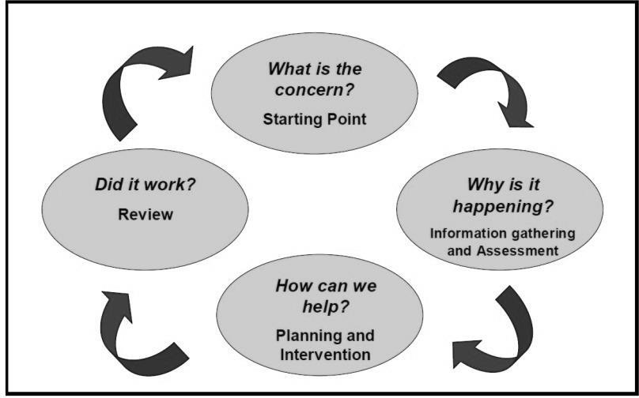

Identification of educational needs is central to our policy and the new allocation model. By using the Continuum of Support framework, we can identify learners’ educational needs, to include academic, social and emotional needs, as well as needs associated with physical, sensory, language and communication difficulties.

This, in turn, allows us to identify and respond to needs in a flexible way.

## The Continuum of Support suggests the following levels of support:

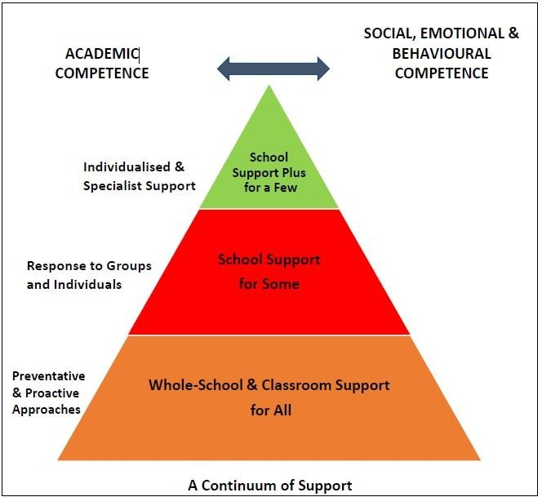

### STAGE 1 CLASSROOM SUPPORT

Classroom Support is the most common, and typically the first response to emerging needs. It is a response for learners who have distinct or individual educational needs and who require approaches to learning and/or behaviour which are **additional to or different** from those required by other learners in their class. Problem-solving at this level typically begins when a parent or teacher has concerns about an individual learner. The teacher, Coordinator and parents discuss the nature of the problem and consider strategies which may be effective. Classroom Support incorporates the simple, informal problem-solving approaches commonly used by class teachers to support emerging needs.

### STAGE 2 CENTRE SUPPORT

In some cases, interventions at classroom support level are not enough to fully meet the learner’s special educational needs. Centre Support may, therefore, be required. The class teacher needs to involve the Special Education Teacher Team (Resource Team) in the problem-solving process at this point and it involves more systematic gathering of information and the development and monitoring of a Centre Support Plan.

### STAGE 3 CENTRE SUPPORT PLUS

If a learner’s special educational needs are **severe and/or persistent**, they are likely to need intensive support. Centre Support Plus will generally involve personnel outside the centre team in the problem solving, assessment and intervention process. However, the information from Classroom and Centre Support work will provide the starting point for problem-solving at this level. Classroom support and centre support will continue to be an important element of his/her individual education plan.

The flow diagrams below outline how we gather information to identify needs and support children with additional needs. A more comprehensive explanation of each stage can be in the Continuum of Support – Guidelines for teachers;

[https://www.education.ie/en/Centres-Colleges/Services/National-Educational-Psychological-Service-](https://www.education.ie/en/Schools-Colleges/Services/National-Educational-Psychological-Service-NEPS-/neps_special_needs_guidelines.pdf) [NEPS-/neps_special_needs_guidelines.pdf](https://www.education.ie/en/Schools-Colleges/Services/National-Educational-Psychological-Service-NEPS-/neps_special_needs_guidelines.pdf)

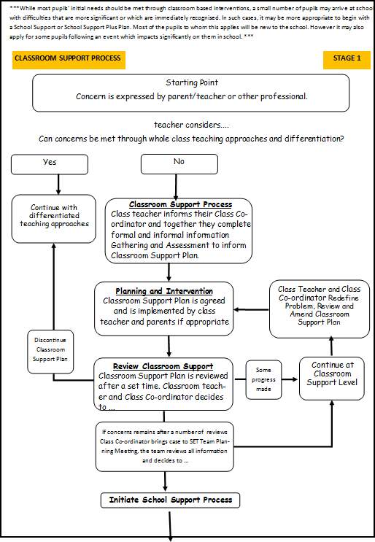

**\*** adapted from NEPS Continuum of Support. For more detailed steps see page 32 - 35 of the continuum of support - Guidelines for teachers

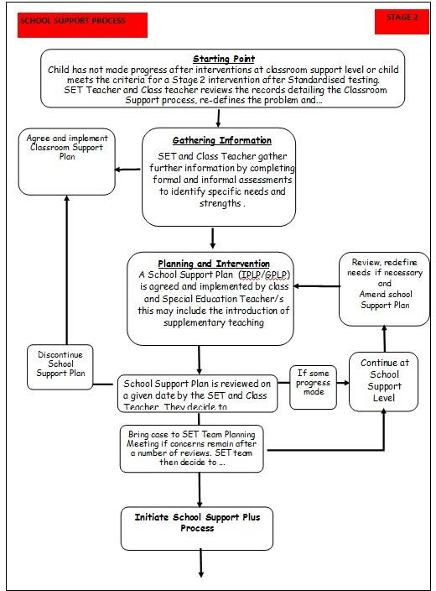

**\*** adapted from NEPS Continuum of Support. For more detailed steps see page 32 - 35 of the continuum of support - Guidelines for

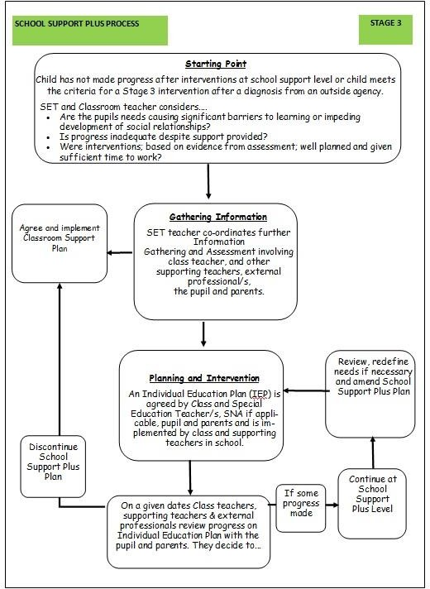

## How does Céim Eile identify Learners for high incident support/learning support?

* + Information from enrolment form indicating that learners have received some learning support in the primary setting
  + Information from previous educational setting
  + Learners who have undergone individual professional assessment and have been diagnosed with a general learning difficulty and or a specific learning difficulty
  + Concerns expressed by parents re their child
  + Result of Standardised tests – the WRAT4 / WIAT test. This test is organised by the Resource Team
  + Learners, from analysis of end of term tests, that are performing poorly – Examination Reports
  + Learners that are presenting as a concern because continuous displays of poor behaviour – Evidence – Teacher Concerns through Negative / Positive Points system and Reporting system
  + Learners that are presenting as a concern because frequent unexplained absences – evidence - Roll Call and Sign-out book
  + Learners that are presenting as a concern because of social or emotional problems – referral forms, Resource team concerns, conversations observed within the centre

The range of teaching support will include Team Teaching, small group teaching and where necessary individualised teaching. – Circular 0070/2014

### Induction Meetings

Induction meeting will be arranged for all learners who are joining the programme. Generally these are held in the Summer months but can occur throughout the year. The purpose of these meetings is to gather and share information. This meeting will look at general information as well as focus on issues including:

* Nature of SEN
* Supports availed of in previous educational setting
* Support required to assist the learner in Céim Eile
* Strategies that work well
* Jobs that need to be done – documentation that needs to be followed up etc
* Create a road map for the way forward

It is hoped where possible that the meeting will be attended by

* + Parents/Guardians
  + Representatives of our centre (Coordinator)
  + External agencies working with the learners – CAMHS representative, OT, Family Support Worker, Social Worker

## Curriculum Review of a Learner

From time to time the curriculum that a learner is following may need to be review in light of request made or concerns raised. This review may lead to modified curriculum.

These concerns/requests can emanate from a number of places

* + A request from the Resource Team
  + Learner is struggling academically as evidenced by class work
  + A request made by class teacher
  + Poor Academic performance and repeated poor performance is impacting on wellbeing –behaviour, attendance, difficult to get to centre, refusal to come to centre
  + Standardised test present a profile that indicate a low level of ability
  + A recommendation from an external agency – CAMHS
  + A request from an external agency
  + A request from parent/guardian
  + A request from the learner
  + A learner who is becoming overwhelmed and is struggling to cope with the challenges that the curriculum have presented
  + Other Strategies employed have made little impact on performance
  + A learner that has experience significant trauma and as part of a reintegration plan may require a modified curriculum.
  + To create a necessary access point for resource support

### Protocol for Decision on modification of Curriculum

* + Gather/Assemble relevant information/documentation
  + It is important that the proposed modified curriculum can be supported through available resources.
  + Set up a meeting with centre management, Coordinator, Parents / Guardians, Guidance Counsellor, Resource Team to discuss curriculum of Learner
  + Curriculum modification may have implications for access to programmes and career paths. It is therefore very important that parents are made aware of all the implications of the changes discussed. The Guidance Counsellor is best placed to provide information re the implications of any curriculum modification
  + It is very important that the learner is consulted with and afforded the opportunity to have an input into their revised curriculum. Parents / Guardians and the guidance counsellor have a role here
  + The parent / guardian is the person who must make the final decision and sign off on the new agreed modified curriculum

## Learner Support – Emotional / Behavioural Needs

A number of learners within the centre system required support arising out of emotional / behavioural needs. These needs can be very complex and challenging for both the learner and for the centre to cope with. The centre resource team works with many vulnerable learners as does the Guidance Counsellor. Some of these learners are engaged with external agencies, some are not. As part of the programme, a counsellor is available to work with the learners. This support is available twice a week and any learner, regardless of need, is afforded the opportunity to see the counsellor. By supporting these learners with this intervention, the knock on effect is that learners and staff member also feel supported.

### How does the system work?

On Induction the Coordinator seeks permission for the learner to access the service (induction booklet; signed by learner and parent / guardian if under 18). The learner must be willing to engage.

All learners are afforded the same opportunity initially. Throughout the year priority of access may be given to learners who

* + Are presenting with emotional behaviour difficulties within the centre system
  + Learners that have experienced trauma, bereavement, illness and require support
  + Despite efforts and strategies employed within the system continue to present challenges
  + Staff within the centre have concerns for

Focus of the Intervention

* + Provide a forum for the learner to discuss issues of concern to them
  + Provide an opportunity to reflect on behaviour and emotional display
  + Seek to set goal to work on
  + To work towards improvement
  + To consult with parent
  + To link with external agencies if required

The level of access is dependent on the level of need. Some learners may need weekly appointment, some 2 appointments a week, some once a month. This is dependent on the level of need at various times. The service needs a level of flexibility. The support worker and learner will together will decide on the level required.

# Reasonable Accommodations in State Examinations

Identification of Learners who may qualify for Reasonable Accommodations in State Examinations

The RACE Instruction for centres which covers all aspects of the RACE scheme is the definitive handbook on RACE. The previous circulars which underpinned the RACE scheme (Department of Education 40/94, 11/00, and 70/00 and SEC 24/12) are revoked and replaced by the information contained in the RACE Instruction for centres document. This document is available from [www.examinations.ie](http://www.examinations.ie/) in the circulars section. This document together with appropriate application forms is sent to centre.

## Key Features of the RACE Scheme

* Accommodations that were provided at Junior Cycle will be reactivated at Leaving Certificate subject to confirmation by the centre authority of an identified and continuing need.
* The category of ‘Specific leaning Difficulty’ has been broadened to a new category known as ‘Learning Difficulty’. Eligibility should be accessed based on level of need, without a requirement for a diagnosis of a specific condition.
* The role of NEPS has changed. They are no longer involved in considering applications instead their role is to provide support and training to centres on the RACE scheme.

T**here are a number of grounds under which an application for Reasonable Accommodations may be applied for: Learning Difficulty**. The following are some of the accommodation that may be applied for in this category.

* + Access to a Reader
  + Reading assistant to read occasional words or phrases
  + Waiver from the assessment of spelling, grammar and punctuation in the language subjects
  + Exam reading pen to scan text and convert it to speech
  + Use of Tape Recorder or Word Processor
  + Access to a scribe

Other grounds for RACE can be accessed and are on an individual basis. They will be sought given the presentation of the learner on an annual basis where necessary and appropriate.

## How is this managed within Céim Eile?

The challenge is to identify all learners who because of a temporary, permanent or long-term disability have special assessment needs in examinations.

Identification of Eligible Learners (*reasonable accommodations co-ordinator*)

* + An analysis of Standard Tests –WIAT III, Reading fluency and sample of Handwriting

An analysis of Educational Assessments. A recommendation alone cannot be taken as automatic qualification. **All criteria set out by the state examinations commission must be met before accommodations will be granted.**

* Previous allocation of RACE will be utilisied and learners will be asked about this on application to the course. If present, this information will be included on the learners centre file.
* Sometimes it is clear from the existing documentation that the learner meets criteria. The learners view re accommodations needs to be ascertained
* The parents view re accommodations for their son/daughter needs to be ascertained. Do they wish to apply for reasonable accommodations on their son’s/daughter’s behalf?
* The resource team carries out any testing that may be required. This testing is completed at various stages during the year. Leaving Certificate Applied are applied for in October of their Leaving Certificate year.
* Sometimes even after this process there remains uncertainty around eligibility, it may be necessary for the Resource Team to consult with the SEC for clarification and assistance.
* Forms are completed by the Resource Team and signed by the Coordinator. The reasonable accommodations coordinator then discusses the form with the learner and parent and gets the Parent / Guardian and / or Candidate to sign it.
* The centre is notified of the outcome of the application process within a specified period of time. The Coordinator alerts the Resource Team and the examination secretary to the outcome of the process. The examinations secretary works to ensure that the relevant accommodations are facilitate during the state examinations.
* The Coordinator notifies learners and Parents of the outcome.
* The Resource Team notifies all relevant personal including class teachers. This is to facilitate the practise of doing examinations with the accommodations.
* It is desirable that learners be afforded the opportunity to practice doing examinations with the accommodations. This may not always be possible given the level of resources required. But where possible every effort will be made to facilitate the learner completed one/two of their mock examinations with the accommodations granted to them. This is provided the SEC has returned documentation supporting the accommodation granted.

### Irish Exemption Circular 0053/2019

This circular governs the rules under which an Irish Exemption can be granted. This procedure should be read in conjunction with Circular Letter 0053/2019 and Exemptions from the Study of Irish: Guidelines for Post-Primary Centres (English – Medium) issued 28th August 2019.

Circular States;

* 1. *The grounds for making an application for exemption from the study of Irish*

*Section 2.2 of Circular 0053/2019 sets out the exceptional circumstances in which consideration may be given to granting a learner an exemption from the study of Irish:*

* + 1. *learners whose* ***education up to 12 years of age (or up to the final year of their primary education) was received outside the state*** *and where they did not have opportunity to engage in the study of Irish*
    2. *learners who were previously enrolled as recognised learners in a primary or post- primary centre who are being re-enrolled after a period spent abroad, provided that at least* ***three consecutive years have elapsed since the previous enrolment in the State and are at least 12 years of age on re-enrolment***
    3. *learners who*
       1. *present* ***with significant learning difficulties that are persistent, despite having had access to a differentiated approach to language and literacy learning in both Irish and English over time.*** *Documentary evidence to this effect, held by the centre should include Learner Support Plans detailing*
* *regular reviews of learning needs as part of an ongoing cycle of assessment*
* *target-setting*
* *evidence-informed intervention and review, including test scores (word reading, reading comprehension, spelling, other scores of language/literacy) at key points of review.*

***and***

* + - 1. *at the time of the application for exemption* ***present with a Standardised Score*** *on a discrete test in either* ***Word Reading, Reading Comprehension*** *or* ***Spelling at/below the 10th percentile.***

A learner must study Irish, unless they have been granted an official Irish Exemption

Learners enrolling in Céim Eile may already have been granted an official Department of Education Irish exemption in another setting. In this case, the official Irish Exemption Certificate must be submitted to the centre authorities with the enrolment form.

Where a learner is applying for an Irish exemption, the following is the procedure to be followed:

* Establish the grounds on which the Irish exemption is being sought – as per circular 0053/2019
* The parent/guardian must make a written application to the Coordinator seeking an exemption from the study of Irish. Parents/guardians must complete Application for Exemption from the Study of Irish Post-Primary Centres (Appendix 2, pg 11 Exemptions from the Study of Irish: Guidelines for Post-Primary Centres (English – Medium) This must contain the grounds under which the exemption is being sought. It must also be accompanied by any relevant documents (eg educational assessment, evidence of age and previous centreing) necessary to provide evidence of eligibility for exemption under the ground applied for.
* The Coordinator passes this application to the Irish Exemption Coordinator.
* The centre must satisfy themselves as to the documentary evidence presented*. (Irish Exemption Co-ordinator)*
* The parent/guardians meet with the Guidance Counsellor. This meeting is to discuss the possible implications of gaining an exemption from the study of Irish on progression to third level instructions and career plans. *(Guidance Counsellor)*
* If at this stage the parent/guardian wish to proceed with the exemption, the Irish Exemption Co-ordinator, completes the certificate (Appendix 5: Certificate of Exemption From the Study of Irish, pg 19 Exemptions from the Study of Irish: Guidelines for Post-Primary Centres (English – Medium)

adhering to the Department of Education guidelines as per circular 0053/2019. The learner and parent/guardian must sign to verify the implications of exemption from the study of Irish. This Certificate is then signed by the Coordinator.

* Checklists for processing applications must by completed by the Coordinator.
* *A copy of the Irish Exemption certificate is issued to parents/guardians.*
* The application plus all relevant supporting documentation together with a copy of the certificate of exemption is retained by the centre and will be made available for inspection by authorised officers of the Department.
* The Department must be notified of learners who are exempted from the study of Irish.

#### **Appeals Procedure**

(pg 8, Section 3.4 Exemptions from the Study of Irish: Guidelines for Post-Primary Centres (English – Medium)

Circular States;

*Where an application for an exemption from the study of Irish is refused, the parent(s)/guardian(s)/learner, may appeal the centre’s decision not to grant an exemption to the Irish Exemptions Appeal Committee within 30 calendar days from the date on which the centres decision was notified in writing (Appendix 6). The appeal will be confined to a review of whether the centre adhered to the guidelines for processing the application for exemption as set out in the Circular and these Guidelines.*

*This written appeal should contain the specific reason(s) why the decision is being appealed by the applicant and the circumstances in which it is considered that the process has not been correctly applied.*

*A parent/guardian/ learner who is unhappy with the outcome of the appeal to the Irish Exemptions Appeal Committee will have recourse to the offices of the Ombudsman for Children if the learner on whose behalf the application is made is under 18 years of age, or to the Ombudsman.*

# Circulars

## Guidelines for Centres and New Allocation Model

[Guidelines for Post-Primary Centres Supporting Learners with Special Educational Needs in Mainstream Centres](https://www.education.ie/en/The-Education-System/Special-Education/Guidelines-for-Post-Primary-Schools-Supporting-Students-with-Special-Educational-Needs-in-Mainstream-Schools.pdf) - [https://www.education.ie/en/The-Education-System/Special-Education/Guidelines-for-Post-Primary-Centres-](https://www.education.ie/en/The-Education-System/Special-Education/Guidelines-for-Post-Primary-Schools-Supporting-Students-with-Special-Educational-Needs-in-Mainstream-Schools.pdf) [Supporting-Learners-with-Special-Educational-Needs-in-Mainstream-Centres.pdf](https://www.education.ie/en/The-Education-System/Special-Education/Guidelines-for-Post-Primary-Schools-Supporting-Students-with-Special-Educational-Needs-in-Mainstream-Schools.pdf)

## [Special Education Teaching Allocation Circular No 0014/2017](https://www.education.ie/en/Circulars-and-Forms/Active-Circulars/cl0014_2017.pdf) https://[www.education.ie/en/Circulars-and-](http://www.education.ie/en/Circulars-and-) Forms/Active-Circulars/cl0014_2017.pdf

## [Special Education Needs](http://www.sess.ie/sites/default/files/DES%20Circular_PP_0070_2014_0.pdf) Circular 0070/2014 –

Guidance for post-primary centres on the provision of resource teaching and learning support - <http://www.sess.ie/sites/default/files/DES%20Circular_PP_0070_2014_0.pdf>

## [Changing Centres Moving from Primary to Post-Primary Centre Guidelines](https://ncse.ie/wp-content/uploads/2016/01/3-NCSE-2016-Changing-Schools-final-web-27.01.16.pdf) for Parents/Guardians of Learners with Special Educational Needs –

## https://ncse.ie/wp-content/uploads/2016/01/3-NCSE-2016-Changing-Centres-final- web-27.01.16.pdf

## [Guidelines on Moving between Mainstream and Special Settings](https://ncse.ie/wp-content/uploads/2016/01/2-NCSE-2016-Changing-Schools-2-final-web-27.01.16.pdf) –

## https://ncse.ie/wp- content/uploads/2016/01/2-NCSE-2016-Changing-Centres-2-final-web-27.01.16.pdf

## [Guidelines on Planning for Life after Centre](https://ncse.ie/wp-content/uploads/2016/01/4-NCSE-2016-Life-After-School-final-web-27.01.16.pdf)

## https://ncse.ie/wp-content/uploads/2016/01/4-NCSE-2016-Life- After-Centre-final-web-27.01.16.pdf

# SNA

Relevant Circulars: <http://www.sess.ie/sites/default/files/DES%20Circular_0030_2014.pdf>

<http://www.sess.ie/sites/default/files/Circular_SP_02_05.pdf>

[http://www.sess.ie/sites/default/files/Circular%2007-02%20SNA%20applications%20&%20role.pdf](http://www.sess.ie/sites/default/files/Circular%2007-02%20SNA%20applications%20%26%20role.pdf)

NCSE provides a Quick Reference Guide to Care Needs - Circulars 07/02 and 02/05

They identify the following **Care Needs** that are consistent with the Department of Education and Skills (DES) circulars.

* Supervising medical needs, over and above what is reasonably expected under the centre’s duty of care.
* Assistance with dressing, feeding, toileting (catheterisation) and personal care.
* Significant mobility and/or access needs due to physical and/or sensory impairments.
* Assistance with accessing or using transport, when an escort is not in situ.
* Assistance for learners with particularly significant difficulties over and above what a class teacher could be reasonably expected to provide e.g. setting up Assistive Technology.
* Dangerous behaviour to self (some detail will be required).
* Dangerous behaviour to others (some detail will be required).
* Significantly disruptive behaviour which is interfering with the learning of others.

## Application for SNA support

* To assist with CARE NEEDS
* A report from a professional is required making a recommendation re SNA support. Identification of the care needs and details of how the SNA support would assist the learner with those care needs.
* Where the primary reason for an SNA application relates to behavioural care needs, the application should be accompanied by the BCN1 form. In completing this report a significant amount of information is required and it will require input from class teachers, LS/Resource teachers, Year Head, learner and parents. Evidence frequency and intensity of behavioural are required eg journal entries, referral forms, behavioural support forms.
* SNA Access is review on a regular basis. SNA support is provided as an interim measure to facilitate the learner’s attendance at centre and minimise disruption to class or teaching time for the learners concerned, or for their peers, and with a view to developing their independent living skills.
* A Centres Care Needs Profile Form A - is completely annually for learners accessing SNA support and submitted to NCSE.
* A Centres Care Needs Profile Form B – is completely for all new application for SNA Support.
* Learners for whom SNA support is being sought under behavioural care needs a BCN (Behavioural Care Needs Record) must also be submitted.
* The SENO will regularly carry out a review of SNA provision within the centre. The SENO will arrange to visit the centre, view those accessing SNA support within the classroom setting and in unstructured areas. Gather information re learner care needs from SNAs, class teaching, LS/Resource teachers, Year Head and centre management. Meet with the parents to discuss the care needs and the appropriateness and level of SNA access. Get the Learners view of the support. Get up to date advice from professionals that are working with the learner re existing care needs. The process is designed to establish the care needs of the learner, identify the level of need that exists, identify how SNA support will be utilised to assist the learner with that need and establish the level of access that is appropriate.

# Assistive Technology

## Relevant Circulars

Circular No 0010/2013

Scheme of grants towards the purchase of essential assistive technology equipment for learners with physical or communicative disabilities

Where assistive technology is recommended on psychological report the Learning Support Coordinator on the instruction of parents may apply to NCSE through the SENO for funding for same. The Department set out clear guideline in the circular (included below) outlining the parameters that the recommendation must include.

Guidelines:

Professional assessments and documentation required

1. Supporting documentation must be submitted to the SENO when making the application. This should include a recent comprehensive and professional assessment of the nature and extent of disability, and details of the equipment most appropriate for the needs of the learner. It may involve a psychological assessment, occupational therapy report, physiotherapy report and/or speech/language report.
2. Applications for equipment will be considered on the basis of the following criteria:
   1. That the professional who assesses the child has made a recommendation that assistive technology is
   2. essential for the effective education of the child, including illustrating how the equipment will be used. (An assessment indicating that equipment would be beneficial, desirable, useful or would achieve improvement in performance will not be sufficient since this could be true in the case of anychild.)
   3. Other than in respect of children in category A above, centres will be required to show that they have engaged in sustained efforts to meet the identified needs of the child through appropriate interventions eg teaching the necessary skills, putting in place appropriate accommodations (as evidenced in IEPs), including utilising the centre’s current information technology provision.
   4. That the case is made or that evidence is supplied that demonstrates that the child will need the recommended equipment throughout the centre day. (Some children may, for example, require theuse of a computer only for a short period during the day – such a requirement should be met from within the IT resources already available within the centre.)
   5. That it is clear that the existing equipment in the centre is insufficient to meet the child's needs without unduly depriving other children of access to the equipment.
3. When grant aid is approved the Learning Support Coordinator sources and orders the equipment which is then used by the learner in consultation with the resource teacher.

# Special Education Needs Glossary Of Terms

1. **ADHD:** Attention Deficit Hyperactivity Disorder**:**
2. **ADD:** Attention Deficit Disorder:
3. **Age appropriate:** Within the child’s chronological age
4. **Age Norms:** The average performance of an individual in various age groups
5. **ASD:** Autism Spectrum Disorder**:**
6. **Bell Curve** is the theoretical normal distribution
7. **BESD:** Behaviour Emotional and Social Difficulties.
8. **DEIS:** Delivering Equality of Opportunity in Schools
9. **DES:** Department of Education and Science
10. **Disability Codes**

|  |  |  |
| --- | --- | --- |
| **No** | **Category of Special Educational Need** | **Incidence** |
| 1 | Physical Disability | Low |
| 2 | Hearing Impairment | Low |
| 3 | Visual Impairment | Low |
| 4 | Emotional Disturbance | Low |
| 5 | Severe Emotional Disturbance | Low |
| 6 | Borderline Mild General Learning Disability | High |
| 7 | Mild General Learning Disability | High |
| 8 | Moderate General Learning Disability | Low |
| 9 | Severe/Profound General Learning Disability | Low |
| 10 | Autism/Autistic Spectrum Disorders | Low |
| 11 | Specific Learning Disability | High |
| 12 | Assessed Syndrome | Low |
| 13 | Specific Speech and Language Disorder | Low |
| 14 | Multiple Disabilities | Low |

1. **Dyscalculia:** A learning disability affecting mathematical ability
2. **Dysgraphia** is a specific learning disability that affects written expression.
3. **Dyslexia:** Learning disability affecting reading ability.
4. **Dysorthographia** is a learning disability that causes chronic issues with spelling and/or writing.
5. **Dyspraxia:** Impairment or immaturity in the organisation of movement
6. **Dysphasia:** language disorder marked by deficiency in the generation of speech, and sometimes also in its comprehension, due to brain disease or damage.
7. **EBD:** Emotional Disturbance and/or Behavioural problems**:** Having a long standing, severe condition that adversely affects personal adjustment, social relationships and learning
8. **EPSEN:** Education for Persons with Special Educational Needs (EPSEN Act)
9. **Fine motor:** Hand and finger small muscle movement, co-ordination and control.
10. **General Learning Disabilities**: Conditions resulting in significantly sub-average intelligence, ranging in severity from Borderline, Mild, Moderate, Severe and Profound levels. (Full Scale IQ Scores)

**Borderline (Circular 08/02 App. II)**

|  |  |
| --- | --- |
| * 70 – 79 | Borderline |
| * 50–69 | Mild |
| * 35 – 50 | Moderate |
| * 20–35 | Severe |
| * < 20 | Profound |

1. **Gross Motor:** Co-ordinated movements of all body parts including the arms and legs
2. **Individual Education Plan:** An Individual Education Plan (IEP)
3. **Multiple Disabilities**: Two or more special education conditions occurring in the same person at the same time
4. **NCSE**: The National Council for Special Education
5. **NBSS:** National Behaviour Support Service – now merged with the NCSE
6. **NCCA:** National Council for Curriculum and Assessment
7. **Physical Disabilities**: Having a condition which impairs the normal development of muscle activities e.g. cerebral palsy, spina bifida, loss of limbs; a category of special education
8. **SID:** Sensory Integration Disorder
9. **SPD:** Sensory Processing Disorder
10. **SMD:** Sensory Modulation Disorder
11. **Sensory Impairments:** Sensory impairment is when one of your senses; sight, hearing, smell, touch, taste and spatial awareness does not function to full capacity.
12. **Specific Learning Disability:** A child with average or above average potential has difficulty learning in one or more areas and exhibits a severe discrepancy between their ability and achievement
13. **SEN:** Special Educational Needs
14. **SENO:** The Special Educational Needs Organiser
15. **SET:** Special Education Teacher/ Special Education Team
16. **SLD:** Speech and Language Disorders**:**
17. **SESS:** Special Education Support Service
18. **SNA:** Special Needs Assistant
19. **In-Class Support:** Team Teaching - Within the classroom, certain teaching strategies have been identified as helpful to the inclusion of learners with special educational needs where more than one teacher is involved in the lesson. Examples include:
    * One Teach – One Drift
    * Parallel Teaching
    * Team Teaching
    * Station Teaching
    * Alternative Teaching

# Future Objectives

1. To continue raising teacher consciousness of learners’ need for learning support and resource teaching
2. To regularly review forms for recording information eg profile forms etc
3. To empower teachers, through professional development opportunities and regular assistance from the Resource Staff, or other relevant professionals, to meet the needs of the great diversity of learners with special educational needs found in our centre
4. To review the communication channels available to inform staff members of the increasingly diverse range of learners with special educational needs who join our centre community
5. To encourage all teachers involved in the provision of resource teaching to participate in professional development in this area
6. To research and purchase relevant academic works which explain the details of specific and general learning difficulties and the impact these have on a learners learning
7. To further engage the participation and support of parents in the learning process
8. To continue developing a whole centre literacy promotion aimed at increasing literacy levels throughout the centre
9. To further strengthen links with other support professionals or agencies to support the centre community
10. To devise a coherent strategy to maximise the support offered by Special Needs Assistants
11. To develop the IT provision in the centre as an effective tool for learning support
12. To empower learners with Special Educational Needs to voice their own concerns and be proactive, working with the centre to address these concerns
13. To review the adequate provision of SEN information to all teachers in line with GDPR guidelines
14. To review how best to share targets for SEN learners with class teachers

# Review

This policy will be reviewed by the Board of Management once in every college year.

|  |  |
| --- | --- |
| Submitted to Staff: |  |
| Submitted to Board of Management: |  |
| Submitted to ETB Board: |  |