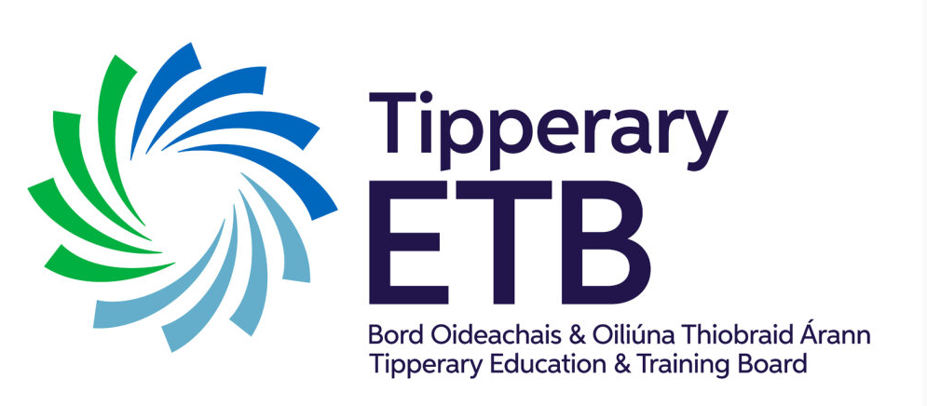 Tipperary Education and Training Board (ETB)

TCFE AND CÉIM ÉILE

COMMUNICATIONS POLICY

**Version**: 1

**Last updated**: June 2023

Contents

Céim Eile Communications Policy 3

Policy 3

Aims of the Policy 3

Purpose: 5

Staff involved 5

Communication with Staff 6

Purpose: 6

Staff involved: 6

Communication with other Stakeholders 8

Purpose: 8

Staff involved: 8



**Céim Eile, Templemore College of Further Education (TCFE)**

**Communications Policy**

|  |  |
| --- | --- |
| Policy Area | Schools |
| Document Reference number | See Attached |
| Version | To be inserted by HO |
| Document Drafted by | **Céim Eile, TCFE** |
| Date Adopted by TETB | To be inserted by HO |
| Reviewed/Amendment | Summer 2023 |
| Date Review/Amendment Adopted | To be inserted by HO |

“Youthreach is co-funded by the Government of Ireland, the European Social Fund and the Youth Employment Initiative as part of thE European Social Fund Plus (ESF+) 2021-2027.”

Funded by the Irish Government and part-financed by the European Union under the

National Development Plan

Príomh Oifigeach Feidhmiúcháin: Bernadette Cullen

# Céim Eile Communications Policy

## Policy

Céim Eile aspires to enhance the learning capacity within the Centre through both internal and external communication. Tipperary ETB’s Education Plan suggests:

‘*Communication in this sense is about much more than information exchange. It is about drawing on the expertise of the staff, students and Boards and sharing the expertise to maximize the use of limited resources. It is fundamentally about building and sharing our vision of education, so that, as a team, we can deliver a first class education service*’.

Communication is more than information exchange. It is about building and strengthening relationships between staff, Learners and other stakeholders. Effective communications will enable the centre to respond to the needs of all. It is the policy of Céim Eile to build and share our vision of education through the establishment of a communication system which shares relevant information and responds appropriately to the needs of all stakeholders.

## Aims of the Policy

1. To facilitate authentic participation of all partners/stakeholders so that Céim Eile’s objectives are agreed and implemented on an ongoing basis
   * Outcome – Engaged and motivated partners/stakeholders
2. To ensure that everyone who is a partner/stakeholder understands and accepts what is expected of them and what they can expect from Céim Eile
   * Outcome – Ethical and responsive partners/stakeholders
3. To communicate with stakeholders/partners using a range of media, in a manner that is timely, relevant, accurate and complete and to ensure feedback is facilitated and encouraged
   * Outcome – Respected and appreciated partners/stakeholders
4. To protect and enhance Céim Eile’s image
   * Outcome – Loyalty and pride in our colleagues and our organisation

***Communication with Learners***

Purpose:To have an effective communication process in place so that all Learners have the facility to give feedback on their experiences of programmes and services.

Staff involved**:** Centre Co-ordinator,Resource Staff, Centre Advocate, Adult Education Officer, Tutor,Guidance Service and Learners.

Learners will be encouraged at the beginning of a programme of study to bring to the attention of the Centre Co-ordinator,Resource Staff, Centre Advocate, Adult Education Officer, Tutor,Guidance Service any issues affecting their full participation on the programme.

Learner Evaluation Sheets will be completed

See Information Provision, Access Transfer and progression

The centre proposes to use the following methods when communicating to our Learners:

* Written notes, to include feedback to and from learners, end of session reports completed by Resource persons, Tutor, and Centre Co-ordinator, as appropriate
* Minutes of meetings
* Learner and Staff Evaluation Sheets
* Written notes completed by Centre Co-ordinator

## Communication with Staff

Purpose: To have an effective communication process in place so that all staff involved in delivering services and programmes leading to QQI and State Examinations Commission certification receive information relevant to programmes and services. This process should also enable staff to contribute feedback and suggestions for improvement to the programmes and services in which they are involved.

Staff involved:Centre Co-ordinator,Resource Staff, Centre Advocate, Adult Education Officer, Tutor,Guidance Service and Learners.

Information regarding new developments and /or upcoming events of relevance will be communicated at meetings of staff, or e-mail.

Staff will be encouraged and facilitated to bring any suggestions for improvement to the programmes and services in which they are involved to the attention of Centre Co-ordinator at staff meetings or at one-to-one consultations

The centre proposes to use the following methods when communicating to our staff:

1. Design a clear diagram and other appropriate communication media to illustrate the organizational structure of our Centre.
2. Create clear diagrams, illustrations, etc that clearly illustrate the decision- making process within Céim Eile
3. Produce and use a range of media brochures, handouts, presentations - to communicate this information
4. Post information materials on the website
5. Use Staff meetings to regularly update regarding structural and decision-making developments
6. Use a range of sources – staff meetings, notice boards, informal discussions, staff newsletter- to initiate policy developments
7. Inform all relevant partners of decisions made on their behalf
8. Relevant stakeholders/partners representation on policy development, consultation and evaluation teams
9. Feedback to contributors regarding their contributions using a range of media including staff meetings and College Newsletter.
10. Céim Eile also proposes to use the following methods of communication
11. Copy of notices and/or e-mail or newsletters
12. Minutes of staff meetings
13. Agendas/minutes of team meetings
14. Staff development days/activities
15. Written notes completed by Centre Co-ordinator, Resource Persons, Tutors, and staff members.

## Communication with other Stakeholders

Purpose:To have an effective communication process in place with individuals and agencies to allow them access information and contribute to programme(s) and services available.

Staff involved:Centre Co-ordinator,Resource Staff, Centre Advocate, Adult Education Officer, Tutor,Guidance Service and Learners.

Front line staff, external agencies, Board of Management, College Principal and Deputy Principal and parents/guardians will be fully informed of all programmes and services available within the Centre.

Enquiries will be acknowledged where appropriate and responded to within seven working days where possible, and will include details of a contact person and telephone number.

Where appropriate Provider personnel will participate in presentations requested by relevant stakeholders to include external agencies, Board of Management, College Principal and Deputy Principal and parents/guardians.

Advertisements will be placed using all forms of communications media including, local and digital media, highlighting upcoming programmes

The centre proposes to use the following methods when communicating to our stakeholders:

1. Design a clear diagram and other appropriate communication media to illustrate the organizational structure of our Centre.
2. Create clear diagrams, illustrations, etc that clearly illustrate the decision- making process within Céim Eile
3. Illustrate points at which relevant partners can inform decision outcomes
4. Produce and use a range of media brochures, handouts, presentations - to communicate this information
5. Post information materials on the website
6. Use Staff meetings to regularly update regarding structural and decision-making developments
7. Use a range of sources – staff meetings, notice boards, informal discussions, staff newsletter- to initiate policy developments
8. Inform all relevant partners of decisions made on their behalf
9. Relevant stakeholders/partners representation on policy development, consultation and evaluation teams
10. Feedback to contributors regarding their contributions using a range of media including staff meetings and College Newsletter
11. Céim also propose to use the following methods of communication
12. Prospectus
13. Promotional material
14. Induction pack
15. Copy of written queries
16. Record of written acknowledgement
17. E-mails
18. Website
19. Copy of presentation
20. Copy of advertisement(s)

**Review**

This policy will be reviewed by the Board of Management once in every school year.

|  |  |
| --- | --- |
| Submitted to Staff: |  |
| Submitted to Board of Management: |  |
| Submitted to ETB Board: |  |