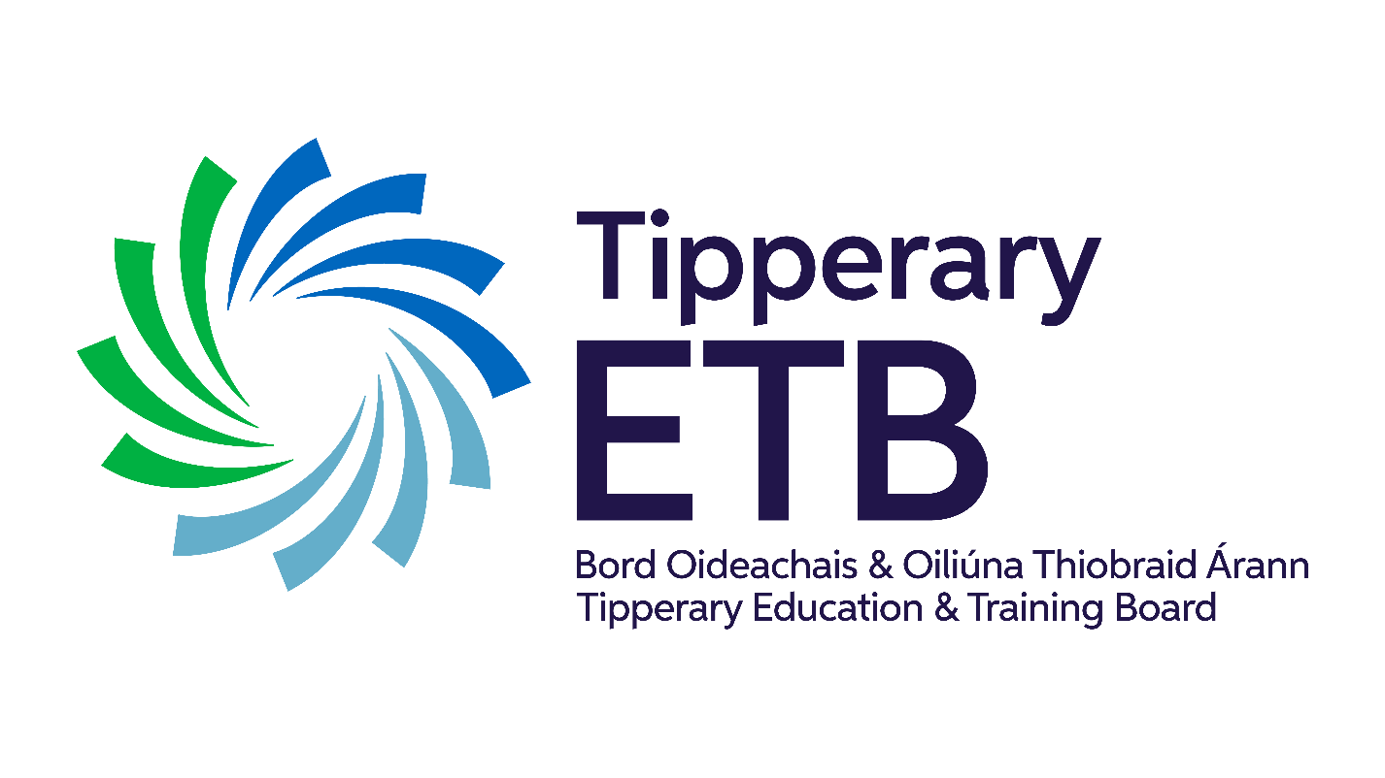

Tipperary Education and Training Board (ETB)

Céim Eile Youthreach

Access Transfer and Progression Policy

**Version** 1

**Last updated**: 07/06/2023

Table of Contents

Introduction 4

1. Policy Statement 4

2. Background/Context 5

3. Definition of Access, Transfer and Progression (ATP) 5

Access 5

Transfer 5

Progression 6

4. Related Policies 6

Admission Policy 6

Recognising Prior Learning 6

5. Policy Implementation 7

5.1Access 7

Pre-Entry Access 7

Access 7

Induction 8

5.2Transfer 9

5.3Progression 9

6**.** Appeals 10

7. Responsibility 10

8. Cessation of programme 11

9. Acronyms Utilised in this Policy 11

10. Monitoring Evidence of Implementation 13

**Céim Eile, Tipperary ETB**

**Access, Transfer and Progression**

|  |  |
| --- | --- |
| Policy Area | Further Education and Training |
| Document Reference number | See Attached |
| Version |  |
| Document Drafted by | **Céim Eile, TCFE** |
| Date Adopted by TETB |  |
| Reviewed/Amendment | June 2023 |
| Date Review/Amendment Adopted |  |

“Youthreach is co-funded by the Government of Ireland, the European Social Fund and the Youth Employment Initiative as part of thE European Social Fund Plus (ESF+) 2021-2027.”

Funded by the Irish Government and part-financed by the European Union under the

National Development Plan

Príomh Oifigeach Feidhmiúcháin: Bernadette Cullen

|  |  |
| --- | --- |
| **Provider Name:** | Céim Eile and Tipperary ETB |
| **Policy Area:** | Programmes of Education and Training  Information and Data Management  Public Information and Communications |
| **Purpose:** | The purpose of this policy is to set out Céim Eile and Tipperary ETB FET Service’s[1] approach to Access, Transfer and Progression (ATP) routes for all pre-entry access enquiries, applicants, and registered[2] learners provided by Céim Eile and Tipperary ETB and/or procured by us.  The policy also includes Céim Eile and Tipperary ETB’s approach to the access, transfer and progression appeals process to ensure applicants who have not been offered a place on a course, have the opportunity to request feedback and to appeal a decision where appropriate.  This policy enables Céim Eile and Tipperary ETB to deliver its education and training programmes to the highest standard, in a fair, equitable and transparent manner. |
| **Scope**: | This policy applies to all programmes of learning delivered by Céim Eile and Tipperary ETB FET and/or procured by Céim Eile and Tipperary ETB with varying access, transfer and progression routes depending on the nature of the provision and the programme requirements. |

# Introduction

Céim Eile is committed to the provision of training programmes that meet the needs of all current and prospective learners and recognises that lifelong learning promotes and facilitates, access, transfer and progression. Céim Eile will ensure that learners have access to information in relation to the training programme, entry requirements for the programme, arrangements for recognition of prior learning, transfer and progression opportunities, programme adaptations and learner supports.

In accordance with FET procedures Céim Eile adheres to TETB Policy on Access, Transfer and Progression.

# 1. Policy Statement

Céim Eile and Tipperary ETB Access, Transfer and Progression (ATP) Policy is committed to providing a fair and consistent approach to Access, Transfer and Progression for all applicants and registered learners to the Further Education and Training (FET) Service.

This policy describes the purpose and commitment to providing effective, appropriate, and clear pathways for access, transfer and progression in line with admission, programme entry requirements and procedures**.** Céim Eile and Tipperary ETB is committed to promoting equitable access to and successful participation in our provision for all members of our community. This is facilitated through the provision of flexible learning opportunities such as full and part time, day and evening, classroom based as well as online. In tandem with the flexible provision is significant collaboration and targeted strategies with the community and voluntary sector, educational institutions and employers. Céim Eile and Tipperary ETB also recognises these collaborative partnerships as measures to progress equity of access to underrepresented groups.

# 2. Background/Context

This policy is informed by the following legislation:

* [QQI Policy Restatement: Policy and Criteria for Access, Transfer and Progression in relation to Learners for Providers of Further and Higher Education and Training (NQAI 2003, Restated 2015).](https://www.qqi.ie/sites/default/files/media/file-uploads/ATP%20Policy%20Restatement%20FINAL%202018.pdf)
* [Qualifications and Quality Assurance (Education and Training) Act 2012](https://www.irishstatutebook.ie/eli/2012/act/28/enacted/en/html), [Qualifications and Quality Assurance (Education and Training) (Amendment) Act 2019](https://www.irishstatutebook.ie/eli/2019/act/32/enacted/en/print),
* [Quality and Qualifications Ireland (QQI) Core Statutory Quality Assurance Guidelines (QQI 2016)](https://www.qqi.ie/sites/default/files/media/file-uploads/Core%20Statutory%20Quality%20Assurance%20Guidelines.pdf)
* [Disability Act 2005](https://www.irishstatutebook.ie/eli/2005/act/14/enacted/en/html)
* [Data Protection Act 2018](https://www.gov.ie/en/publication/65865-data-protection-act-2018/)

# 3. Definition of Access, Transfer and Progression (ATP)

Access, Transfer and Progression describes pathways that facilitate applicants and registered learners to enter, transfer between, and progress from programmes of education and training, which are the main route to achieving awards and qualifications. The definition of access, transfer and progression is as follows;

Access – the process by which applicants and registered learners may commence a programme of education and training having received recognition for prior knowledge, skills or competence acquired

Transfer – is the process by which registered learners may transfer from one programme of education and training to another programme having received the knowledge, skills and competence acquired within one NFQ level; and

Progression – is the process by which learners may progress from one programme of education and training to a higher NFQ level programme in FET, or to Higher Education and Training (HET), or into employment.

# 4. Related Policies

### Admission Policy

Admission requirements are specified and are appropriate to the type and level of the provision. The admission age of an applicant/learner to all FET provision is 16 years[3] upwards and those aged 15 years (or less) may, as an exceptional measure be considered eligible subject to referral to the Chief Executive (CE) of Tipperary ETB for approval.

### Recognising Prior Learning

Recognition of Prior Learning (RPL) is a process to evaluate the skills and knowledge a person has gained through formal, non-formal or informal learning or a combination of all these. Formal learning is gained through completing certified courses. Non-formal or informal learning is gained through work, voluntary activities or study for which no certification may have been obtained. In Céim Eile and Tipperary ETB Recognition of Prior Learning (RPL) can be granted for entry, advanced entry to a programme, or for claiming exemption(s) from element(s) of a programme. Where applicable, applicants are invited to forward the required documentation to Céim Eile coordinator where eligibility of access, transfer or progression will be decided in line with the provision admission policies, procedures and entry criteria, including the programme specific entry requirements.

# 5. Policy Implementation

This policy has been informed by the QQI policy restatement “Policy and Criteria for Access, Transfer and Progression in Relation to Learners for Providers of Further and Higher Education and Training” (NQAI 2003, restated 2015).

Céim Eile and Tipperary ETB commits to providing and publishing clear, accurate and accessible information on access, transfer and progression in a standardised format that is relevant to programme type, entry requirements and NFQ level.

## 5.1Access

### Pre-Entry Access

Céim Eile and Tipperary ETB commits to make available to prospective applicant's relevant entry information and this is supported through a range of measures and supports as follows:

* Provision of clear and impartial information and guidance
* Support on recruitment, admission, application and registration process
* Information on learner supports including the application process for specific learner groups, such as learners with disabilities, learners whose mother tongue is not English etc
* Information on programme content and whether or not a programme leads to an award, the awarding body, title of the award, and if the award is recognised in the National Framework of Qualifications (NFQ), the award type and level
* Arrangements for eligibility to enter, including a statement of knowledge, skill and competence needed by the applicant as a basis for successful participation on the programme, and where relevant, the attainments required in the award
* Transfer and progression opportunities associated with the award

Access (entry) to the initial stage of a FET programme is gained through:

* Standard entry i.e., by meeting the minimum educational and programme entry requirements
* Non-standard entry i.e., recognition of both formal and non-formal learning for access to a programme
* Non-EU/EEA national applicants are requested to provide evidence of eligibility
* Assessment for recognition of prior learning (RPL) is specific to each programme/course and will be considered and may be granted for entry to a programme, for claiming exemption(s) from modules of a programme or for advanced entry to some programmes. Assessment for eligibility for RPL will follow Céim Eile and Tipperary ETB RPL procedures (and/or criteria)
* As applicable to the provision, official transcripts/documentation may be requested to evidence formal learning
* A programme assessment or screening may be required to ensure applicants meet the required skills, knowledge, and competencies for entry and to ensure learners' successful participation in the programme. Based on the outcome of assessment/screening an alternative course may be suggested to the applicant and / or referral to the guidance service.
* Céim Eile and Tipperary ETB may refer an applicant to an alternative course placement or opportunity, or guidance, if it is deemed that applicant does not meet the minimum standard and/or non-standard entry criteria

### Induction

Induction is the process of formally welcoming a registered learner to a programme in Céim Eile and Tipperary ETB FET Service and this is usually at the venue of programme delivery. The induction process may differ depending on the mode of delivery, duration of the course and whether it is full-time or part-time, accredited or unaccredited. Céim Eile and Tipperary ETB is committed to supporting all learners with clear and accurate information on access, transfer and progression.

The purpose of induction is to:

* familiarise new learners with all aspects of their learning environment
* build a learning community by establishing relationships with their peers and with staff
* provide learners with an opportunity to share and address any concerns or questions they may have
* provide an overview of the programme, including the responsibilities of learners for their own learning
* distribute general learner information pack/guides (handbooks, quality assurance handouts / manuals, list of student supports)
* outline learner supports available and how to access these

## 5.2Transfer

Céim Eile in conjunction with Tipperary ETB FET Service provision includes unaccredited programmes and programmes that are aligned on the National Framework of Qualifications (NFQ) from levels 1 to 6 including QQI, City and Guilds, ICDL, CIBTAC, Microsoft, and many other industry specific awarding bodies.

This wide-ranging provision provides opportunities for learners to transfer to others awards at the same NFQ Level. Our provision may facilitate learners with the opportunity to accumulate credits and work towards achieving a major award at a pace that suits them.

## 5.3Progression

Céim Eile and Tipperary ETB provides opportunities for learners to progress on a modular part time and full-time programme basis to higher NFQ in FET, or to Higher Education and Training (HET) or into employment.

Céim Eile and Tipperary ETB will provide information on clear progression pathways into FET, within FET and from FET to facilitate ongoing lifelong vocational and career engagement.

# 6**.** Appeals

Céim Eile and Tipperary ETB allows all learners to appeal decisions made in relation to Access, Transfer and Progression if they are dissatisfied with any element of the application process in line with published policy and procedures. Appeals is the process by which an applicant, or registered learner, may appeal a decision relating to access, transfer or progression.

Feedback can be sought verbally or in writing directly from the Programme Coordinator/ Centre Manager. If not satisfied with the outcome of the feedback at centre/programme level a written appeal can be submitted.

A written appeal must be submitted to [dyoung@tipperaryetb.ie](mailto:dyoung@tipperaryetb.ie) or [appeals@tipperaryetb.ie](mailto:appeals@tipperaryetb.ie) no later than 3 days from receipt of application decision, and a review will be carried out by an appeals committee and who is independent of the programme manager/coordinator.

The appeal outcome is final. The decision can be further investigated by the person making the appeal with the Office of the Ombudsman if necessary.

# 7. Responsibility

The Programme Coordinator/Centre Manager has responsibility for the management of entry to a programme including; clear and accurate marketing and advertising, recruitment, application and allocation of places, and the registration process. In some instances, the Programme Coordinator/Centre Manager will be supported by teachers [4], Resource persons and the Adult Guidance and Information and Recruitment service.

The Programme Coordinator/Centre Manager with responsibility for accredited provision must ensure that information relating to certification is clear to applicants and information is shared in a timely manner relating to the appropriate certification approval board, to facilitate progression opportunities.

Resource persons and teachers have responsibility to liaise with the Programme Coordinator/Centre Manager in respect to transfer and progression opportunities.

The Programme Coordinator/Centre Manager has responsibility to provide feedback to an applicant if an appeal is raised. Where a formal appeal is submitted the Céim Eile and Tipperary ETB Quality Assurance Office, they will organise an independent review to facilitate the appeals process.

# 8. Cessation of programme

Céim Eile and Tipperary ETB will provide learners with information about arrangements that are in place where a programme ceases and will endeavour to assist and accommodate impacted learners in access and transfer to alternative provision.

# 9. Acronyms Utilised in this Policy

**CIBTAC:** Confederation of International Beauty Therapy and Cosmetology

**FET:** Further Education and Training

**ICDL:** International Certificate of Computer Literacy

**NFQ:** National Framework of Qualifications

**QA:** Quality Assurance

**QQI:** Quality and Qualifications Ireland

**RPL:** Recognition of Prior Learning

**Internal Monitoring System**

|  |  |  |
| --- | --- | --- |
| **Method(s) used to carry out the monitoring** | **Who does it?** | **Frequency** |
| Respond to feedback from stakeholders and update policy accordingly | QA Governance Group with QA Office and QA Steering Group | As required in response to matters arising |
| Formally review policy | QA Governance Group with QA Office and QA Steering Group | Every 5 years, or as appropriate |

|  |  |
| --- | --- |
| **DOCUMENT CONTROL** | |
| **Dates:** | Created: February 2023 |
| **Created By:** | Quality Assurance Steering Group |
| **Approved By:** | Quality Assurance Governance Group |
| **Versions:** | V1.0 |

|  |  |  |  |  |
| --- | --- | --- | --- | --- |
| **REVISION SUMMARY** | | | | |
| **Revision Type:** | **Update** |  | **Review** |  |
| **Version** |  | | | |
| **Summary of Changes** |  | | | |

# 10. Monitoring Evidence of Implementation

**Céim Eile** monitors the implementation of this **Access, Transfer and Progression Policy.**

Evidence to confirm implementation of the **Access, Transfer and Progression Policy** will include, for example:

ETB website; contacts with stakeholders,

Intranet (if/as applicable),

IT helpdesks,

ETB/Training Centre Service Plans,

Customer Charter (where appropriate),

Promotional materials,

Learner feedback forms and surveys,

Follow-up survey of learners.

1. Céim Eile and Tipperary ETB FET ‘Service’ refers to all programmes and related services.
2. The term ‘registered’ learners is used in Céim Eile and Tipperary ETB in lieu of the term ‘enrolled’ learners as per the Qualifications and Quality Assurance Act 2012
3. Parental/Guardian consent is required for persons under 18 years of age.
4. The term ‘teacher’ means teacher, tutor, trainer, instructor, adult educator and learning practitioner